**Assignment 2 – Dataset preparation Part 1**

**Objective:** Build a face image datasetfor two classes: Aliens vs Zombies

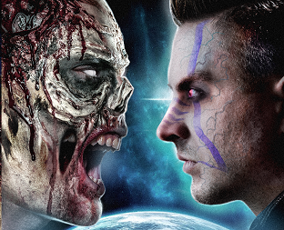

**Step 1**: **Download** 10 face images of zombies and aliens for each class, keep in separate folders. Note: Images can be in any format.

**Step 2**: **Read** the images from two different folders. Automate the process. Avoid mentioning the paths of the images manually. Use built in functions of popular libraries for reading images.

**Step 3**: **Standardize** all theimagesinto standard square size (for example 100*100*3). Use the following strategies and leave the choice to users.

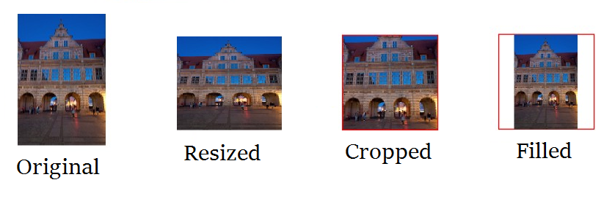

**Step 5**: **Stack** all the image data into a single array of size 20*100*100*3. Now this array is now the dataset we wanted to build.

**Step 6**: **Create** different variants of the dataset we created in the previous step.

* Convert all images into grey scale and create a grey scale dataset.
* Convert all images into binary image and create a binary image dataset.
* Flatten all images into 1D vector and create a dataset

**Step 7**: **Store** the datasets physically into disks numpy array files (in npy format) and also hdf5 format.

**Suggested Platform:** Python: Azure Notebook/Google Colab Notebook, packages such as numpy, Skimage, opencv

**Marking:** Marking is based on both **performance during the lab hours** as well as **complete submission**.